Golf Flexibility Program

There are a variety of flexibility exercises that can enhance your golf game. If you are currently injured, you need to see a sports medicine doctor to get the right Rx. If you are looking to improve your strength and flexibility, do the stretches listed in this handout.

Hold all stretches for a predetermined amount of seconds and perform the predetermined amount of repetitions. This amount is generally what we discussed or what your doctor recommends. Perform all stretches slowly, remember to breathe and STAY RELAXED!
AS we discussed, NEVER bounce or rock back and forth. Stay relaxed and in control.

For example: Go into the stretching motion and allow about 5-10 seconds to get to the position of max stretch. Hold that position for at least 3 seconds but not longer than 10 seconds. Slowly, and I mean SLOWLY, let go of the stretch and gently move back to the starting position. Did you breathe?

Neck and Upper Body: I like to start up and work down towards the ground.

1. Neck Stretch. Place right hand on top of head – Slowly pull head towards the right shoulder. Switch hands.


2. Posterior Shoulder: Standing balanced, grasp under left elbow with right hand and pull slowly across chest. Switch arms.

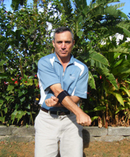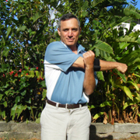

* Advanced: Take address position stance with appropriate spine angle and perform the same stretching motion.

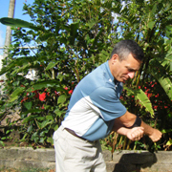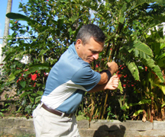

3. Chest Stretch: Hold a golf club behind you with your hands facing forward. Slowly raise arms behind you while keeping the elbows from bending.

* Advanced: Try different hand positions on the club, for example hands closer or wider to your sides as a starting position.
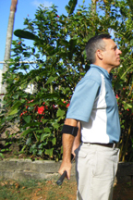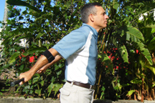

4. External Rotation: Hold head of golf club in right hand with the club hanging off the back of the arm and parallel to the forearm. With the left hand reach up and grasp the grip and slowly raise forward.

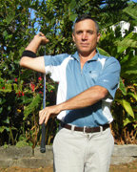

5. Internal Rotation: Hold head of golf club in right hand and dangle the club behind you on the same plane as your spine. Reach back around with your left hand and allow the right hand to slowly pull up. Switch hands.

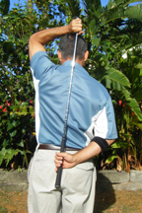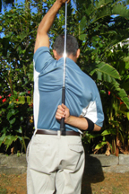
6. Wrist Stretch: With elbow straight out and palm facing up, slowly pull hand down bending at the wrist. Then try the same stretch with the palm facing down. Switch arms

6. Wrist Stretch: With elbow straight out and palm facing up, slowly pull hand down bending at the wrist. Then try the same stretch with the palm facing down. Switch arms

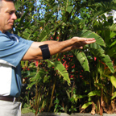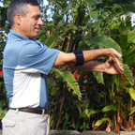

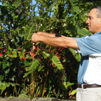
Lower Extremity (Trunk)

1. Side Bend Stretch: Stand with feet shoulder width apart. Hold golf club over your head and slowly lean to left side. Switch sides.

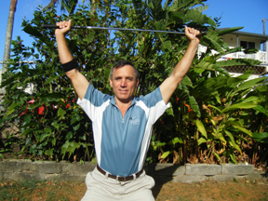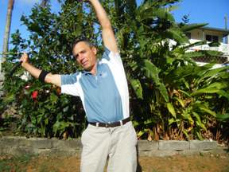

2. Low Back Stretch: Always use caution when the spine is supporting weight in a “backwards” motion. Stand with hands supporting the lower back barely above your buttocks and slowly lean backwards.
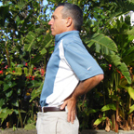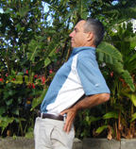

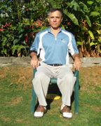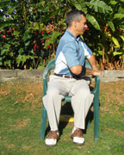
3. Seated Rotation: Sitting, back straight, feet shoulder width and facing forward. Keeping seated portion from turning, reach across your body and hold the opposite side arm rest. Switch sides.
.
4. Standing Rotation: If seat is not available: Standing. Back straight; feet shoulder width and facing forward. Reach down and across your body with your right arm to the furthest belt loop you can comfortably turn to. Use your left hand to stabilize your hip and keep it from turning to the left. Switch sides

Front Angle Oblique Angle
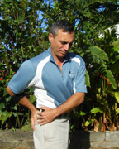

5. Hamstrings: Sitting on edge of bed, sofa, or golf car seat. Keeping right leg completely straight and toe pointing upwards; slowly lean forward. Make sure to keep your back straight and bend forward at the hips. Switch legs.

6. Hip Stretch: Lie on back with knees bent. Rest left ankle on right knee and slowly push left knee away from you. Switch legs.

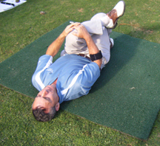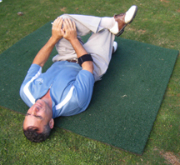

7. Hip/Butt Stretch: Lie on back with knees bent. Rest left ankle on right knee and slowly pull left knee toward right shoulder. Switch legs.

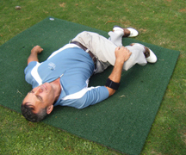
8. Lying crossover: Lie flat on back with left leg straight. With both or either arm, grasp right knee and pull across your body towards the opposite hip. Try and keep your shoulders flat on the floor.

9. Lying Trunk Rotation: Lie on back with knees bent and feet flat on the floor. Rotate knees to one side; hold, then back to the other side and hold.

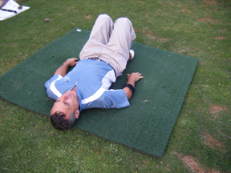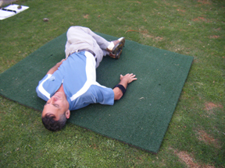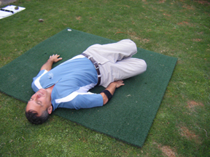

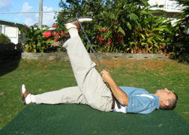
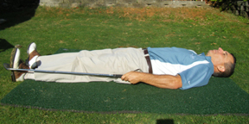
10. IT Band Stretch: Lie flat on back and hook golf club around underside of foot. Keeping the knee straight, slowly raise the foot toward the opposite shoulder. Switch sides.

